## Scenarios:

1. A **chemical plant just exploded**! Resulting from an unexpected chemical reaction, a part of the building collapsed and there are many people still inside. Their position is unknown and it is not safe for humans to come in the blind.
2. An **earthquake destroys half of a hospital** and interrupts most of the electrical systems. Now it's important to rescue all the patients lying in the intensive care unit. The way towards them is really dangerous because of collapse and also many objectives block many parts of the way.
3. **Fukushima incident**

(earthquake + tsunami/flood)

radioactive & hot environment (dangerous for people)

1. a breach in a dam and an urban area nearby is flooded

## Task lists:

1. Find victims(casualties)
2. Navigate & explore
3. Bring supplies (Medical only for contaminated zones, food for normal zones)
4. Communicate
5. Remove obstacles

## 

## Requirement Elicitation

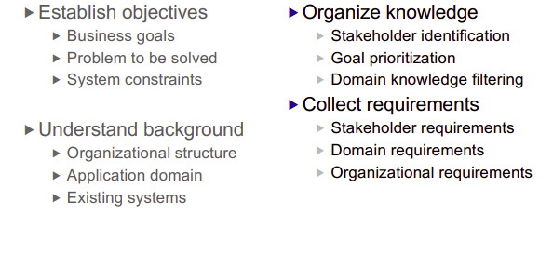

* Establish objectives
* Business goals: Build a robot that can assist in rescuing and locating people.
* Problem to be solved:
  + Navigation through tough terrain + amphibious.
  + Move through areas/Mobility.
  + Pathfinding.
  + Communication in difficult areas.
* System constrains:
  + Power capacity - length of time of operation.
  + Size to travel through the area.
  + Toughness to withstand impact.
  + Torque strength.
  + Load limit.
  + Mobility to navigate through rough terrain.
  + Range of communication (signal).
  + Density must be lower than water (997 kg/m³) so that it can float.
  + Low weight.
* Understand background:
* Organizational structure:
  + Startup company:
    - Manager
    - Finance
    - Marketing
    - Research and development
    - Design
    - Quality assurance
    - Consultances
* Application domain:
  + Fire rescue
  + Flood assistance
  + Disaster relief
  + CBRN rescue (Chemical, biological, radiological and nuclear)
* Existing system:
  + Amphibious Vehicles
  + Fire fighting + EOD robots
  + Communication devices
  + Drones
* Organize Knowledge:
  + Stakeholders:
    - Investors
    - Company staffs
    - Users (firefighters, police, government, paramedics, patients)
  + Goal prioritization

|  |  |
| --- | --- |
| 1 | Remote control |
| 2 | High mobility (Amphibious, rough terrain, small areas) |
| 3 | Support rescue (Nav. robot + Carry supplies) |
| 4 | Element resistant |
| 5 | Power efficiency |

* Collect requirements:
  + Stakeholders requirements:
    - Profitable
    - Safe to use
    - Easy to use
    - Reliable, available, safe, secure, maintainability
    - Adhere to regulations
  + Domain requirements:
    - Has to work in various harsh environment
    - Controller knowledge
    - Wireless communication knowledge
    - Robotics knowledge

## Requirement Analysis

Are the answers consistent? identify trouble spots identify boundaries identify most important requirements

Trouble spots:

* Fire damage
* Environment corrosiveness
* How to float on water ,being amphibious,
* Impassable obstacles (mobility)
* power capacity
* remote control in long distance + interference
* water seepage (possible short circuit)

Boundaries:

* Size
* Mobility
* Range of operation
* Materials
* Budget
* Knowledge
* Current tech
* Carry load (for the supplies and obstacles)

## Requirement Validation

## Diagrams